Henley in Arden Memorial Hall
Fire Risk Assessment
A safety guide for users of the hall
Assessment by the Committee Members, July 2026
Description of Premises
Henley in Arden Memorial Hall is a is a flexible event venue, able to host a variety of personal events or community events. It meets all current building regulations regarding fire hazard and disabled access. The building comprises one entrance lobby having a cloakroom, separate men’s, women’s and a disabled toilet, cooking and water-heating is by gas.
There is a main hall which the County Fire Officer certifies to accommodate: 200 persons dancing with no tables or chairs; 200 persons closely seated (with gangways of 1.05 metres to all exits); 90 persons seated at tables with dancing. Doors lead to a side and a rear room, which can hold up to a maximum of 50 persons for all activities. There is a stage with "working" lights, 3 spot lights, and a modern high definition projector / and automatic screen. There is a level approach to the front of the hall via the car park. The modern kitchen offers some catering facilities. Lightweight tables and comfortable stacking chairs are available. There is a car park with barrier control. There is Free WiFi available throughout the building.
Four emergency exits lead directly out of the building - from the main hall and side lounges and back room. They are clearly lit with emergency lighting.
The designated ASSEMBLY POINT is the Car park.
The Hall is NO SMOKING area. It is a criminal offence to smoke on the premises. There is a cigarette bin positioned at the front of the building.
No FIREWORKS, PORTABLE GAS APPLIANCES or FLAMMABLE SUBSTANCES are permitted inside the building.
Fire extinguishers are situated in the kitchen, meeting room, main hall, and side rooms. They are routinely inspected. The certificate is held at the registered address. Last inspection July 2026.
Fire Hazard is medium, and therefore RISK IS MEDIUM.
Principal Uses of the Memorial Hall
The hall is hired by a range of organisations, and private individuals for a wide variety of activities, some of which are licensable. A written agreement between the Memorial Hall and the Hirer forms the basis of the hiring arrangement. The Booking Form and Rules of Hire draw the hirer’s attention to the health and safety and licensing obligations that the Booking places upon them. The Hall holds a license for the sale of alcohol. Licensable activities authorised by the licence and the times the licence authorises the carrying out of licensable activities. Sale of Alcohol on the Premises Thursday to Saturday 19:00 - 22:30, Plays Thursday to Friday 19:00 - 22:30 Saturday 19:00 - 23:00, Films Thursday 19:00 - 22:30. Private Hirers, are responsible for meeting the obligations of the license, and must seek permission from the committee to serve or sell alcohol.
The Committee encourage all users of the Hall to carry out their own Fire Risk Assessment, highlighting the areas that pertain to their own group of users and their activities.
This Fire Risk Assessment has been done by the Committee to cover all aspects of the Hall, but in particular for those Hirers who are not familiar with the layout and equipment. THE HIRER IS DEEMED THE “RESPONSIBLE PERSON” AND IS DESIGNATED AS THE PERSON IN CHARGE OF THE HALL DURING THE HIRE PERIOD.
It is advisable to take a note of the name of everyone attending your event. The Committee encourage Hirers to make themselves aware of the exit routes, the firefighting equipment and the plan of the Hall detailing the location of the equipment, the escape routes. The plan is available to all Hall users and is also displayed on the wall by the side entrance.
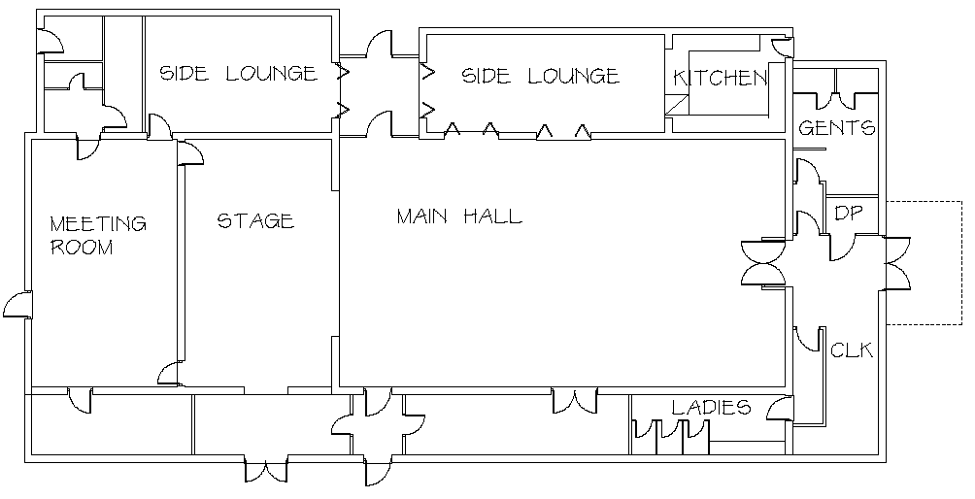
They should also identify the assembly point. It is the responsibility of hirers to ensure the hall is securely locked after use, as the building should never be left open and unoccupied. The main doors are fitted with specialist security locks (which prevent unauthorized keys from being cut), with access to keys being controlled by the Committee. All doors MUST be closed when not in use.

People at Risk
Those at risk in the event of fire are:
• Staff: The Memorial Hall Committee employs a part-time cleaner, who has a key to the building and is generally on her own when working.
• Trades People: The Committee employ local trades people on both an ad-hoc and scheduled basis for the purposes of safety checks and building maintenance. Local trades people who are familiar with the building may gain access to the hall by borrowing a key from the Hirings Secretary, while others are always escorted by one or more Committee.
• Hall Users (up to 210 inside at any time): These will generally be familiar with the hall. Those that aren’t will find the simple layout easy to navigate and assimilate. The main hall area is open plan and has easily identifiable fire exits on 3 sides. Emergency lighting is installed over fire doors and around the hall, and this is tested regularly. There are fire doors in the main hall that exit outside and are fitted with a push-bar release.
• Disabled Persons: At a typical function there may be a limited number of disabled persons. It is the responsibility of hall hirers to ensure disabled persons are given adequate assistance in the event of an evacuation. All emergency exit doors are level inside, but outside steps would need assistance to be navigated. This should be taken into consideration by all users.
• Children: It is the responsibility of hirers to ensure all children within the Hall are supervised and that they are given adequate assistance in the event of an evacuation.
• Other Members of the Public (who are not using the hall)

Possible Causes of Fire
a) Main power supply fault
b) Portable electrical appliances fault
c) Kitchen equipment faults (other than portable electrical appliances)
d) boiler
e) damage to Gas pipes or appliances.
f) naked flames
g) Cooking accidents
h) Waste (accidental ignition)
i) Stage lighting system fault (including dimmer and distribution system)
j) Soft furnishings – accidental ignition
k) Stage scenery and props – accidental ignition
l) Deliberate ignition
Control Measures
The primary and general control measures taken by the Committee are to ensure that:
• Sufficient and correct fire-fighting equipment is available and that a qualified practitioner inspects it at least once per year. Consists of the following: foam and carbon dioxide extinguishers in each room and an additional fire blanket in the kitchen. All extinguishers are located near room exits ensuring accessibility and visibility.
• The advice of the inspection practitioner to increase, change or move location of the firefighting equipment is followed.
• The location of the fire-fighting equipment, emergency lighting and escape routes are clearly marked on a Plan that is displayed on the wall by the front entrance and available to all users and staff.
• All Fire Exit doors are checked for illumination, ease of opening and that the Emergency Exit Routes are clear on a weekly basis. A test of continued illumination in event of a power failure will be done quarterly. A test of the Smoke Alarms will be done quarterly.
• The Committee test the ease of access to and through the escape routes and to the assembly points at least once per year and log the results.
• Any furnishings belonging to the Memorial Hall that are less than one metre from the floor are made of a non-combustible material, or a material that has been Fire Proofed to the standard applicable at the time of purchase. This applies to all curtaining on the stage irrespective of distance from the floor level.
• Security lighting (sensor operated) is provided and maintained to discourage potential intruders.
• A record of key holders is kept. Also a record, by date and session, of those hirers (ie: tutors of regular classes) that have been given temporary access to a key.
• The waste bins are checked each time the kitchen is cleaned for any fire hazards (eg: loose, inflammable materials such as paper). Where any loose material is found it will be placed inside the exterior waste bins or removed from site.
• All Memorial Hall Users will be made aware of their responsibilities under the Premises License via the Booking Form.
• All Regular User Groups will be advised that they should carry out their own Fire Risk Assessment. Whilst the Committee will advise and encourage, they cannot be held responsible for a group not carrying out its own Fire Risk Assessment.
DIAGRAM OF MEMORIAL HALL SHOWING FIRE EXITS
FIRE EXIT
FIRE EXIT FIRE EXIT
FIRE EXIT
Note that the ASSEMBLY POINT is the carpark away from the building.

FIRE!
In the event of a Fire (break glass at Call point)
DIAL 112 or 999
1) The Responsible Person (see page 2) will instruct all persons to leave the building using the nearest available Emergency Exits, and to muster together as soon as possible at the ASSEMBLY POINT – far end of car park
2) A Roll Call should be taken.
3) NO MATTER HOW SMALL THE FIRE, CALL THE FIRE SERVICE. There is no phone onsite. If you have a mobile phone, Dial 112 and give this address: Memorial Hall, Station Road, Henley in Arden, Warwickshire B95 5JP.
4) The Responsible Person should ensure that once the Memorial Hall has been evacuated, members of the public do not re-enter the building to collect personal belongings, etc. under any circumstances.
5) On the arrival of the Fire Service, the Responsible Person should report to the Officer in Charge that a Roll Call has taken place and all persons are safe, or should inform him/her of anyone who is missing from their last known position
6) Attempts to extinguish the outbreak of fire using the fire extinguishers should be only carried out if it is considered to be safe. If any doubt get out of the building.
7) If you have a mobile phone and after you have carried out all of the above, and circumstances allow it, please call 07799694425 (Chairman) or 01564 793539 (Hirings Secretary).
NOTE: All incidents no matter how small have to be reported to the Memorial Hall Secretary Memorial Hall Committee
The emergency evacuation procedure is available as a separate, one page, document.

